Bank Customer Churn
Exploratory Data Analysis — Findings Report

1. Overview
This report summarizes the findings from an exploratory data analysis (EDA) performed on the bank customer churn dataset. The goal of the analysis is to understand the customer base and identify which factors are most associated with customers leaving the bank (churn).
Metric | Value
Total customers | 10,000
Total features (after cleaning) | 11
Missing values | None
Duplicate rows | None
Overall churn rate | 20.37% (2,037 churned out of 10,000)

2. Data Preparation
The raw dataset contained 14 columns. Three identifier columns — RowNumber, CustomerId, and Surname — were dropped since they carry no predictive signal for churn behaviour. The cleaned dataset has 11 columns: CreditScore, Geography, Gender, Age, Tenure, Balance, NumOfProducts, HasCrCard, IsActiveMember, EstimatedSalary, and the target variable Exited.
No missing values or duplicate records were found, so no imputation or deduplication was required.

3. Target Variable: Churn Distribution
Out of 10,000 customers, 7,963 (79.6%) stayed with the bank while 2,037 (20.4%) churned. This is a moderately imbalanced target, which is worth keeping in mind if this dataset is later used for predictive modeling.
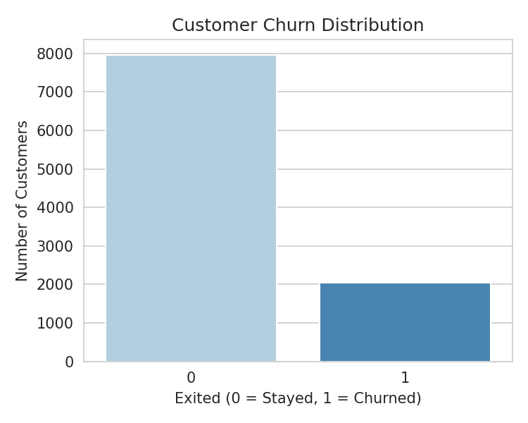
Figure 1: Distribution of churned vs retained customers

4. Key Findings

4.1 Geography
Churn rate varies noticeably by country. Germany stands out with a churn rate roughly double that of France and Spain.
Geography | Customers | Churn Rate
France | 5,014 (50.1%) | 16.2%
Germany | 2,509 (25.1%) | 32.4%
Spain | 2,477 (24.8%) | 16.7%

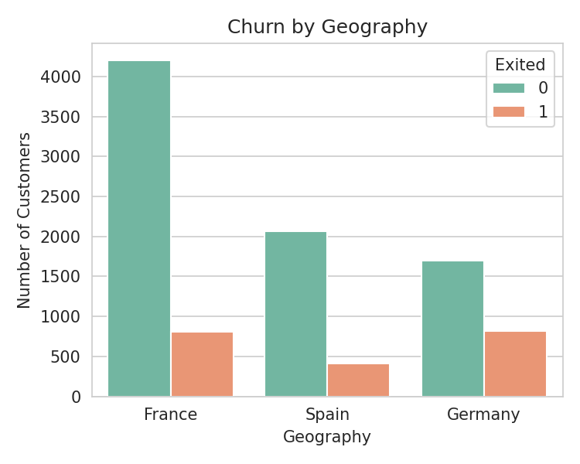
Figure 2: Customer counts by geography, split by churn status

4.2 Age
Age is the numerical feature most correlated with churn (correlation ≈ 0.29). Customers who churned are older on average (mean age ~44.8) than those who stayed (mean age ~37.4). Younger customers are considerably more likely to remain with the bank.
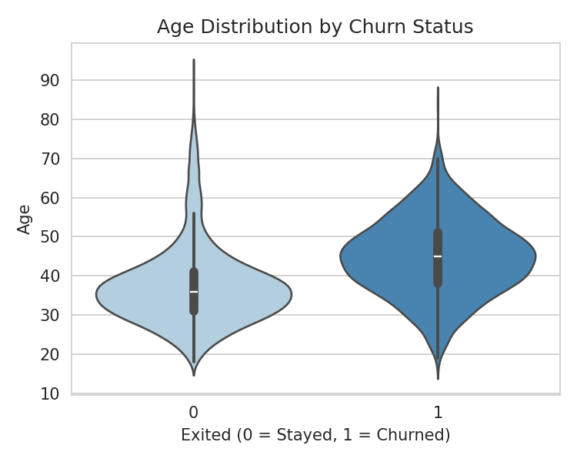
Figure 3: Age distribution for retained vs churned customers

4.3 Number of Products
The number of bank products a customer holds is strongly related to churn, but not in a simple linear way. Customers with 1 product churn at 27.7%, those with 2 products churn at only 7.6% (the lowest rate in the dataset), while customers with 3 or 4 products churn at 82.7% and 100% respectively. This suggests that holding exactly 2 products is the sweet spot for retention, and customers with 3+ products are an extremely high-risk group, possibly because that combination is associated with dissatisfaction or product overlap.
Number of Products | Customers | Churn Rate
1 | 5,084 | 27.7%
2 | 4,590 | 7.6%
3 | 266 | 82.7%
4 | 60 | 100.0%

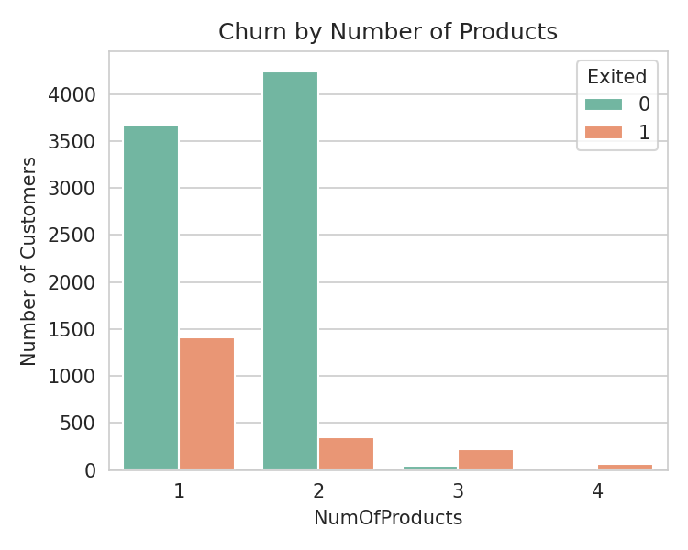
Figure 4: Customer counts by number of products, split by churn status

4.4 Active Membership
Active members churn less often than inactive ones — 14.3% versus 26.9%. Activity level (IsActiveMember) is the second strongest correlate of churn among the available features, after Age.
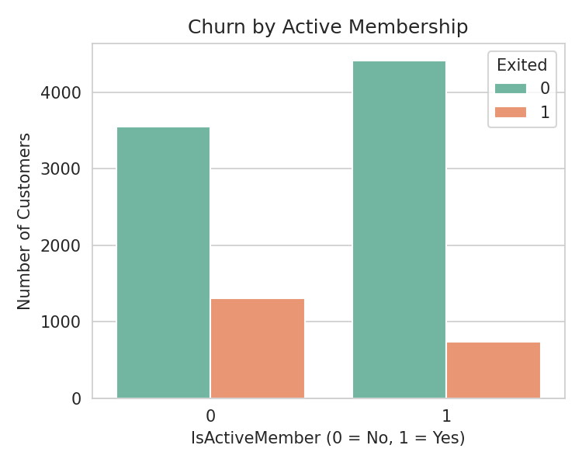
Figure 5: Customer counts by active membership status, split by churn status

4.5 Gender
Female customers churn at a noticeably higher rate (25.1%) than male customers (16.5%).

4.6 Balance
Customers with a zero account balance churn less often (13.8%) than customers with a positive balance (24.1%). On average, churned customers carry a higher balance (~91,109) than retained customers (~72,745), which aligns with the positive correlation between Balance and Exited (≈ 0.12).

4.7 Credit Score, Tenure, Estimated Salary, and Credit Card Ownership
These four features showed little to no relationship with churn in this dataset. Credit score and tenure are both slightly negatively correlated with churn but the effect is weak (correlation magnitudes below 0.03). Estimated salary shows almost no correlation (≈ 0.01), and whether a customer holds a credit card makes virtually no difference (20.8% churn with no card vs. 20.2% with a card).

5. Correlation Summary
Pearson correlation of each numerical feature with the churn target (Exited), ordered from strongest to weakest:
Feature | Correlation with Exited
Age | +0.285
Balance | +0.119
EstimatedSalary | +0.012
HasCrCard | -0.007
Tenure | -0.014
CreditScore | -0.027
NumOfProducts | -0.048
IsActiveMember | -0.156

Note: NumOfProducts has a low linear correlation despite showing a strong relationship with churn in the cross-tabulation (Section 4.3). This is because the relationship is non-monotonic (churn first drops, then spikes sharply), which Pearson correlation does not capture well.

6. Conclusions
- The bank's overall churn rate is about 1 in 5 customers (20.4%), with a moderately imbalanced target distribution.
- The strongest risk signals for churn are: holding 3+ products, being an older customer, being an inactive member, and being based in Germany.
- Customers holding exactly 2 products and active members are the most loyal segments.
- Credit score, tenure, estimated salary, and credit card ownership do not appear to meaningfully influence churn in this dataset.
- Given the non-linear relationship between NumOfProducts and churn, this feature would benefit from being treated as categorical rather than purely numerical in any downstream modeling work.

